

**KULLIYYAH OF INFORMATION AND COMMUNICATION TECHNOLOGY**

**DEPARTMENT OF INFORMATION SYSTEM**

**INFO 4302**

**Group Project Proposal**

**MUSLIM TARBIYAH MOBILE APPS SYSTEM**

**(iMuslimsNotes)**

Zulfani Ahmad Zuhri 1420625

Muhammad Ihsan 1529221

Muhammad Arif Bin Azmi 1624841

Muhammad Fathudzikri Aulia 1411773

**Abstract**

*Learning and evaluating to what extent we have applied what we learn is essential, especially what regards with our life as a Muslim. iMuslimNotes is a mobile apps system which providing a routine Muslim self-daily evaluation and Islamic knowledge. Questionnaires are distributed to gather the information on which criteria of application that is liked most by participants. The application then will be developed to work in Android platform using React Native and Javascript. This application is purposed to help Muslim to evaluate and develop himself through a curriculum that consists of few levels. Each level has standard self-evaluation and Islamic knowledge materials which will be conveyed in articles or slides or multimedia element such video or audio and finished with a quiz to evaluate their knowledge which just learnt before they can reach the next level. The project is then conducted by referring to some organizations that has been used this system in real or factual life.*

# 1. Introduction

Human being is a creature that full of forgetfulness and wrong. There are many daily deeds to be done by Muslims. However, due to their limit they tend to forget and lose from his responsible as Muslims. To solve this problem, the developer built a mobile application named iMuslimsNotes that will ease Muslims to remind them of their obligation, record their daily deeds and even helps them to gain Islamic knowledge in attractive way. The aim of this project is to help Muslim to be a better person by easing them to note their daily activity and serve them with interesting Islamic learning materials. Therefore, this application would provide two main features to solve the issues above which are Islamic daily evaluation and Islamic daily contents.

**1.1 Problems Statements**

* Human being is a creature that full of forgetfulness and wrong
* People sometimes have high motivation for being good but in other time it can decrease or might even vanish.

**1.2. Project Objectives**

* Helps Muslims to record, track, and evaluate their Islamic daily activity.
* To remind user of daily tasks they yet to done.
* To help Muslim upgrading their Islamic knowledge by providing Islamic learning materials.
* To grow Muslims’ motivation to be a better Muslim.

**1.3. Project Scope and Limitations**

iMuslimNotes target audience is only Indonesian because one of the main aim of this application is to upgrade Tarbiyyah method tools in FOTAR IIUM organization that they have their own curriculum which delivered in Indonesian language.

The targeted user of this project is:

* Indonesian
* Malaysian
* Age ranged from 15 years old-50 years old
* Educated people
* Android user

There are some limitation in this project. The first limitation is the language option that offered in this application is only Indonesian language. As the target audience of this project is Indonesian, Indonesian language is chosen as the main language of the application. However, since Indonesian language is only understood by Indonesian people or some people from other countries, the language offered will be a constraint for this application to be used by people from other country who do not speak Indonesian language. The second limitation of this application is the learning materials that is conveyed is taken from other sources so that the content delivered might be slightly out of the curriculum of Tarbiyyah. The third limitation is that this application is only working in Android platform that does not allow other operating systems users using it in their gadgets.

**2. Features and Functionalities**

|  |  |  |
| --- | --- | --- |
| **Features** | **Description** | **Components/API/installation requirements** |
| Sign Up | User registration | Firebase, router |
| Log in | User authentication | Firebase |
| Avatar | Add avatar | UI toolkit: React Native Elements |
| Real time date | Date picker android | UI toolkit: Native Base |
| Bar Chart | Add bar chart | React Native Char Kit |
| Icon & Customize icon | Add icon | UI toolkit: React Native Elements |
| Dropdown menu | Add dropdown menu | reatc native material drop down |
| Router/ Navigator | add navigation between screen | react navigation, react navigation tabs, react navigation stack |
| ScrollView | Add scrollview to scroll vertical and horizontal the page | ScrollView from react ative |
| Dimensions | make dimension for the page | Dimensions from react native |
| Image | Add image | Image from react native |
| Video | Add video | Video from react native video |
| ProgressBar | Add progressbar in video playback | ProgressBar from react native progress/bar |
| Divider | Add line to divide the content of the page | Divider from react native elements |
| ListItem | Add list view for some data | List Item from react native elements |

**3. Methods**

Agile software development is used as an approach in this project. Agile is a methodology in developing a software (Sharma, Sarkar, Gupta, 2012). The word of Agile itself means rapid, easy, and mobile. The concept of Agile software development was initially developed by Kent Beck and his other 16 colleagues. Agile software development differs with other development approach in the way it allows the developer build his software. By using this approach, this project will be divided into few parts and coming with prototype, and testing to rapid feedback in order to minimize changes in system thus will make the process becoming more effective and lessen cost spent.

**3.1 Requirement Engineering**

In order to collect information regarding requirements from users. In this application online survey had been conducted to gather relevant information from users.

The survey was conducted using Google Forms. This survey was aimed to see which option of application that suits most to the users. The link was distributed to IIUM students. Their respective family and friends were also allowed to contribute to the survey by allowing them to forward the link to their relatives. After the survey has been completed the process of analyzing was made to conclude which option has the biggest percentage of people chose.

Intending to accomplish this project, a cyclic process has been practiced. This process involves five stages which are planning, analysis, design, implementation, and maintenance.

**3.2 Development Requirement**

**3.2.1 Development environment:** React Native with Java script plug in for windows.

**3.2.3Android OS :** Android version 2.3.3 “Gingerbread” (API 10) up to Android version 7.0 “Nougat”

**4. Results**

**4.1 Screenshots Examples**

Below are few of screen interface screenshots.

|  |
| --- |
|  |
|  |
|  |
|  |
|  |

**4.2 Navigation Flow**

Below is the navigation flow of the application.

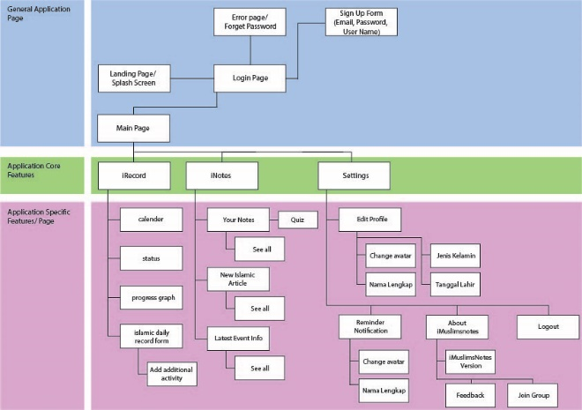

**5. Discussion**

Iterant development is chosen to be applied in the process of making this application. The reason of why the developer chose this development approach is because the application built needs feedback in many parts of the developing process. First the developer distributed questionnaire, analyzing the result got from the information, designing the application, building system, and implementing the application.

There are many advantages that offers by using this approach. One of the biggest advantage is that this approach is thrifty in terms of time and cost spent. By reducing the number of change and preventing problems or larger error. Easier improvements and implementing changes in every part also becomes the reason of why this approach has been chosen.

For future works, the developer suggests some improvement to make the application better. Firstly is to enrich the application with more languages so that people who are using other languages can use this application as well. Secondly, Islamic learning materials is highly recommended for coming from the developer’s own source. By having it’s own source, it would be easier to the developer to provide materials in line with the curriculum followed. Thirdly, the developer recommends to create group features. This feature allows the user to create or join in a group for them to remind one another and compete in doing good deeds among them.

**7. Acknowledgement**

First and foremost, the developer thank Allah, for His blessings so that the developer can finish this project in time given. The developer also would like to dedicate his special thanks to Dr. Ahmad Fatzilah Misman for his kindness to guide the developer to complete this project.

# 8. References

[1] A. Grigore, “Agile CMMI for E-Learning Software Development”, Bucharest, 2009.